NST21022 - Practical for Network Switching and Routing
Department of Information and Communication Technology
Faculty of Technology
Lab sheet :14
Reg. Number: SEU/IS/20/ICT/084
Academic Year :2020/2021
Practical No :14

Title: Configure DHCPv4
Aim:
● Getting familiar with DHCPv4

Task:
● Configure a Router as a DHCPv4 server
● Configure DHCPv4 relay
● Verify DHCPv4 connectivity

Activities
Use “NST21022 Labsheet 14.pka” file
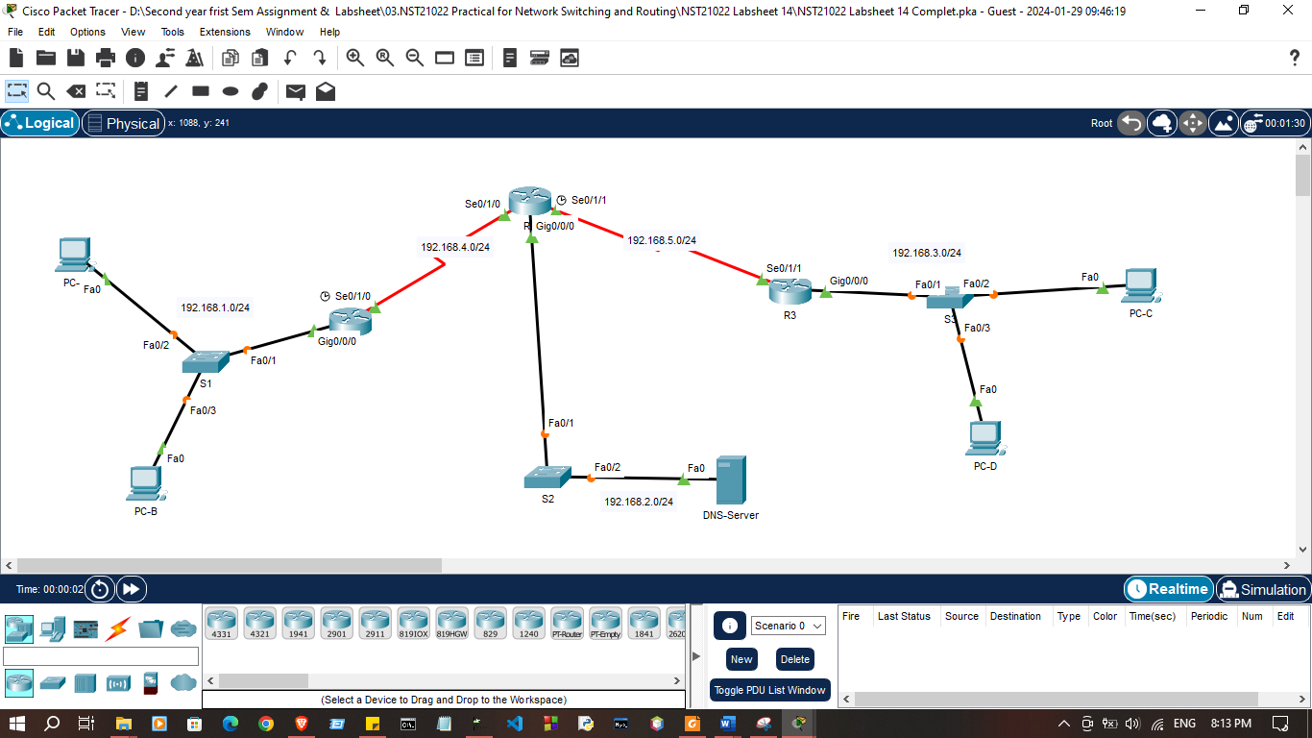

Addressing Table

Device | Interface | IPv4 Address | Subnet Mask | Default Gateway
R1 | G0/0/0 | 192.168.1.1 | 255.255.255. | N/A
R1 | S0/1/0 | 192.168.4.2 | 255.255.255.0 | N/A
R2 | G0/0/0 | 192.168.2.1 | 255.255.255.0 | N/A
R2 | S0/1/0 | 192.168.4.1 | 255.255.255.0 | N/A
R2 | S0/1/1 | 192.168.5.1 | 255.255.255.0 | N/A
R3 | G0/0/0 | 192.168.3.1 | 255.255.255.0 | N/A
R3 | S0/1/1 | 192.168.5.2 | 255.255.255.0 | N/A
DNS-Server | NIC | 192.168.2.10 | 255.255.255.0 | 192.168.2.1
PC-A | NIC | DHCP | DHCP | DHCP
PC-B | NIC | DHCP | DHCP | DHCP
PC-C | NIC | DHCP | DHCP | DHCP
PC-D | NIC | DHCP | DHCP | DHCP

Exercise 01: Configure a Router as a DHCPv4 server
- Configure IP addresses on each device’s according to addressing table.(Except DNS-Server)

R1>enable
R1#configure terminal
Enter configuration commands, one per line. End with CNTL/Z.
R1(config)#
R1(config)#interface g0/0/0
R1(config-if)#ip address 192.168.1.1 255.255.255.0
R1(config-if)#no shutdown

R1(config-if)#exit
R1(config)#
R1(config)#interface s0/1/0
R1(config-if)#ip address 192.168.4.2 255.255.255.0
R1(config-if)#no shutdown

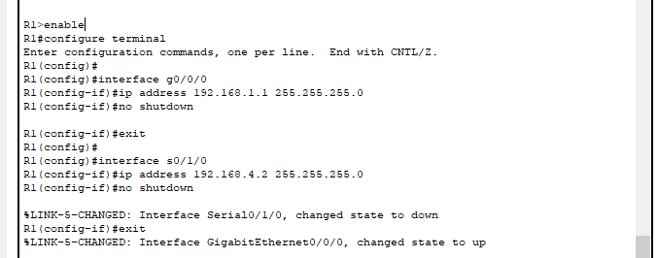
R2>enable
R2#configure terminal
Enter configuration commands, one per line. End with CNTL/Z.
R2(config)#
R2(config)#interface s0/1/0
R2(config-if)#ip address 192.168.4.1 255.255.255.0
R2(config-if)#no shutdown

R2(config-if)#exit
R2(config)#
R2(config)#interface s0/1/1
R2(config-if)#ip address 192.168.5.1 255.255.255.0
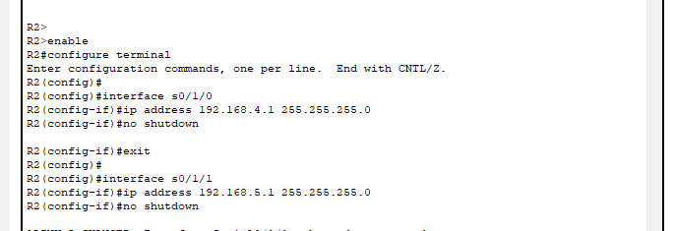
R2(config-if)#no shutdown

R3>enable
R3#configure terminal
Enter configuration commands, one per line. End with CNTL/Z.
R3(config)#
R3(config)#
R3(config)#interface g0/0/0
R3(config-if)#ip address 192.168.3.1 255.255.255.0
R3(config-if)#no shutdown

R3(config-if)#exit
R3(config)#
R3(config)#interface s0/1/1
R3(config-if)#ip address 192.168.5.2 255.255.255.0
R3(config-if)#no shutdown
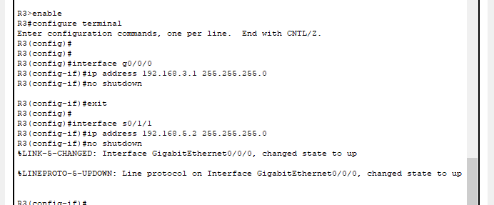

- Configure R2 to exclude the first 10 addresses from the R1 LAN.

R2(config)# ip dhcp excluded-address 192.168.1.1 192.168.1.10

R2(config-if)#ip dhcp excluded-address 192.168.1.1 192.168.1.10
R2(config)#
R2(config)#ip dhcp excluded-address 192.168.3.1 192.168.3.10
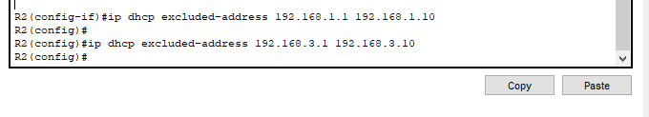
R2(config)#

- Configure R2 to exclude the first 10 addresses from the R3 LAN.

- Create a DHCP pool in R2 for R1 LAN named R1-LAN (Case Sensitive)

R2(config)# ip dhcp pool R1-LAN

R1(config)#ip dhcp pool R1-LAN
R1(dhcp-config)#
R1(dhcp-config)#ip dhcp pool R3-LAN
R1(dhcp-config)#

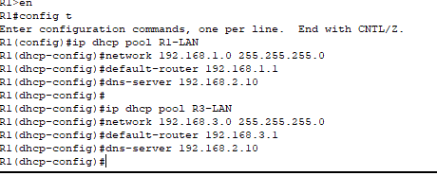

- Create a DHCP pool in R2 for R3 LAN named R3-LAN

R3>en
R3#config t
Enter configuration commands, one per line. End with CNTL/Z.
R3(config)#ip dhcp pool R1-LAN
R3(dhcp-config)#
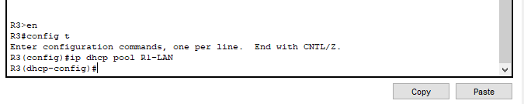

- Configure the DHCP pool to include the network address, the default gateway, and the IP address of the DNS server.
R2(dhcp-config)# network 192.168.1.0 255.255.255.0
R2(dhcp-config)# default-router 192.168.1.1
R2(dhcp-config)# dns-server 192.168.2.10

R2(dhcp-config)#network 192.168.1.0 255.255.255.0
R2(dhcp-config)#default-router 192.168.1.1
R2(dhcp-config)#dns-server 192.168.2.10
R2(dhcp-config)#network 192.168.3.0 255.255.255.0
R2(dhcp-config)#default-router 192.168.3.1
R2(dhcp-config)#dns-server 192.168.2.10

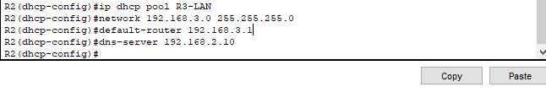

- Configure R1 and R3 as a DHCP relay agent

R1(config)# interface g0/0
R1(config-if)# ip helper-address 192.168.4.1

R1(config)#
R1(config)#interface s0/1/0
R1(config-if)#ip address 192.168.4.2 255.255.255.0
R1(config-if)#no shutdown
R1(config-if)#exit
R1(config)#
R1(config)#interface g0/0/0
R1(config-if)#ip helper-address 192.168.4.1
R1(config-if)#no shutdown
R1(config-if)#exit
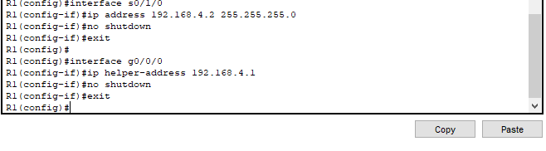
R1(config)#

R3(config)#
R3(config)#interface g0/0/0
R3(config-if)#ip helper-address 192.168.5.1
R3(config-if)#no shutdown
R3(config-if)#exit
R3(config)#

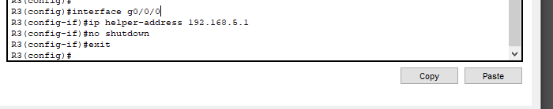

- Configure hosts to receive their IP addresses from a DHCP server
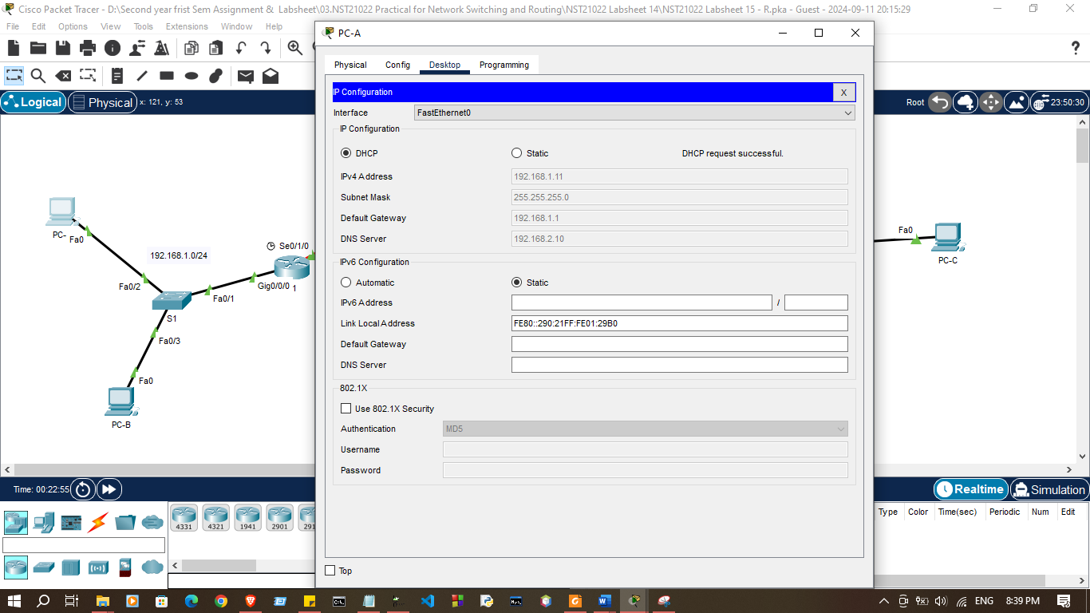

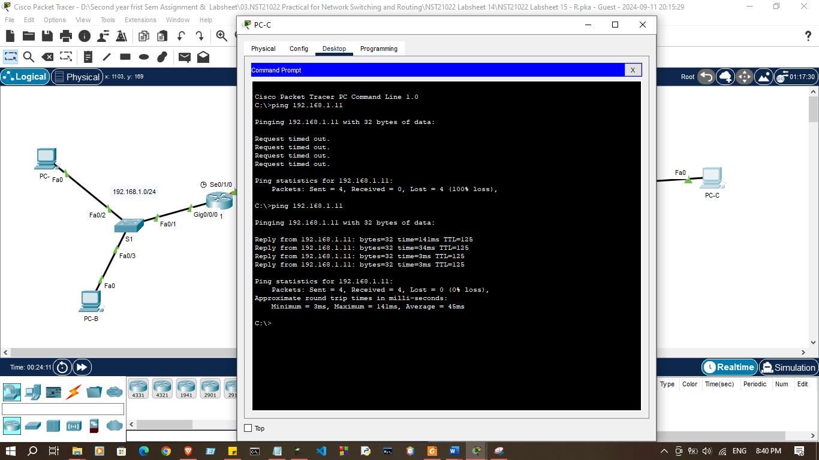
- Verify host IP addresses and connectivity
Discussion
- In this lab session, we focused on configuring DHCPv4 to dynamically assign IP addresses to devices on a network. First, we set up a router to function as a DHCPv4 server, defining the IP address pool, default gateway, and DNS settings to be provided to clients. Next, we configured DHCPv4 relay on an intermediary router to forward DHCP requests from clients in different subnets to the central DHCP server. Finally, we verified DHCPv4 connectivity by ensuring that the devices on the network received IP addresses automatically from the server, confirming successful configuration and communication between the clients, DHCP server, and relay.

